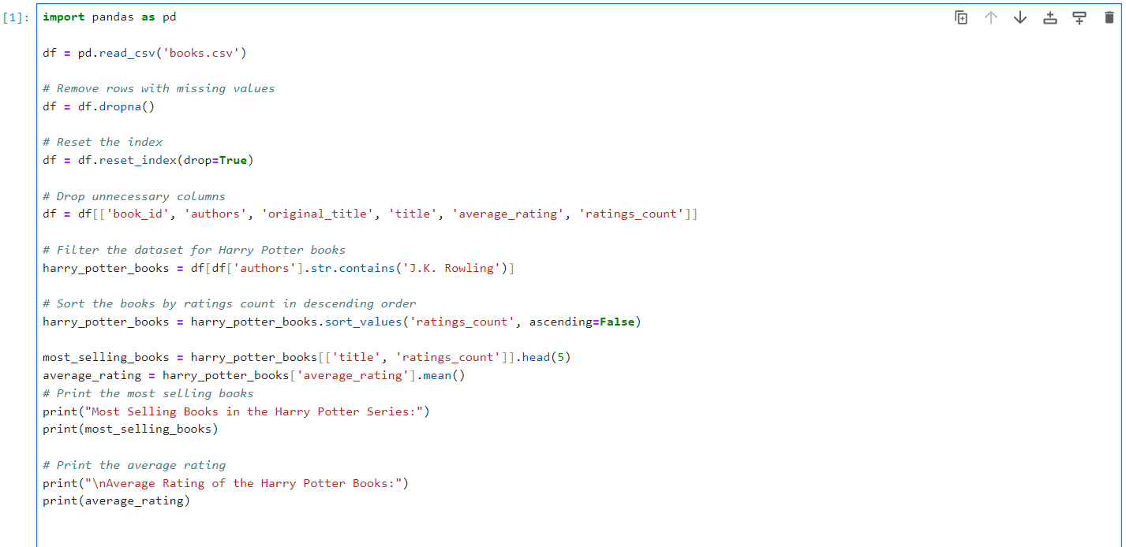

***Cleaning code:***

***“books” after cleaning:***